Objective Test Instructions

District Leadership Conference

2024-25

# Overview of Testing

An objective test, often called an “online test,” is a 100-question multiple choice exam developed by the National FBLA on a set topic. Members are given 50 minutes (30 minutes with 50 questions for Business Ethics) to complete the exam.

# Policies and Procedures

* Iowa FBLA uses Blue Panda eTesting for the objective testing software.
* All tests must be completed in the official testing window pre-set by Iowa FBLA and in one sitting.
* Test scores are released at the close of the conference.
* Iowa FBLA does NOT mandate proctored testing for the district level. Local advisers may choose to proctor students. The local adviser of the chapter may serve as the proctor, or another educator, such as the guidance counselor, outside of the chapter must serve as the proctor. The proctor should see the computer screen at all times.
* Tests should be scheduled with an additional 15-20 minutes to allow time to get set up.
* Using outside websites, electronic devices, or reference materials is prohibited.
* All tests must be taken individually – including team events.
* Iowa FBLA receives all tests from the National FBLA.

# Testing Support

If you have technical issues please contact one of the following individuals for assistance.

## Blue Panda

**Email:** support@gobluepanda.com

**Main phone line:** 256-808-2583

**Backup phone line:** 256-824-0084

## Iowa FBLA

**Email:** info@iowafbla.org or kent@iowafbla.org

**Main phone line:** 866-442-3252

**Backup phone line:** 515-657-8260

# List of Objective Tests

* Accounting I
* Accounting II
* Advertising
* Agribusiness
* Banking and Financial Systems
* Business Communication
* Business Law
* Business Management
* Computer Applications
* Computer Problem Solving
* Cyber Security
* Economics
* Entrepreneurship
* Financial Math
* Future Business Leader
* Healthcare Administration
* Hospitality & Event Management
* Human Resource Management
* Insurance and Risk Management
* International Business
* Introduction to Business Communication
* Introduction to Business Concepts
* Introduction to Business Procedures
* Introduction to Event Planning
* Introduction to FBLA
* Introduction to Financial Math
* Introduction to Information Technology
* Introduction to Marketing Concepts
* Introduction to Parliamentary Procedure
* Journalism
* Management Information Systems
* Marketing
* Network Design
* Networking Infrastructures
* Organizational Leadership
* Parliamentary Procedure
* Personal Finance
* Public Policy & Advocacy
* Securities and Investments
* Sports & Entertainment Management
* Spreadsheet Applications
* Supply Chain Management
* UX Design
* Word Processing

# 

# Objective Testing Instructions

Advisers can follow the instructions below on how to access login cards from Blue Panda at app.gobluepanda.com.

**Step 1:** Advisers/proctors will login to Blue Panda with their normal login to access and print student login cards. Click the bottom button under the conference that you are registered for. Note, this is a new button.

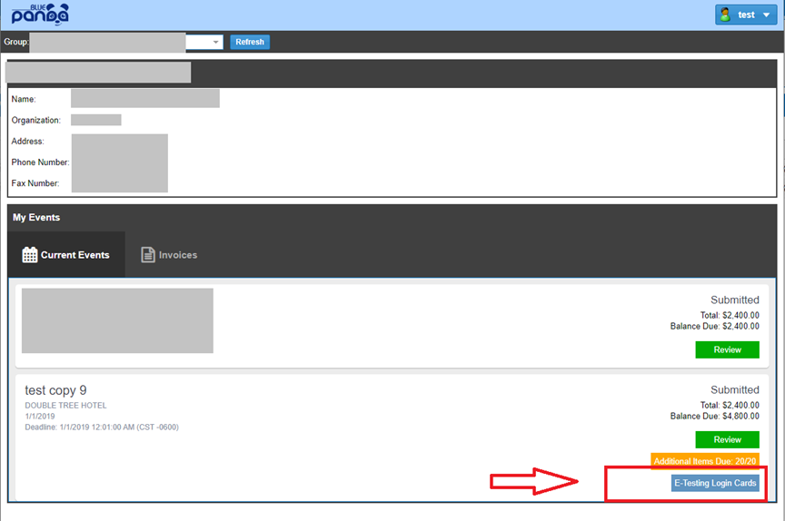

**Step 2:** Click the Login Cards button to view your logins, then click “Print Cards” on the top right to create a PDF to cut up and share with students when they get ready to test.

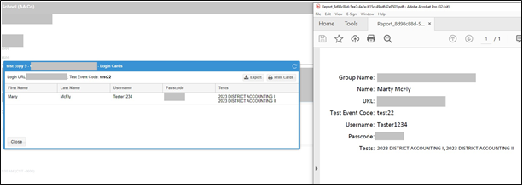

**Step 3:** Begin testing students. Students will go to https://bpet.gobluepanda.com/students/login They will login with the Event Code, Username, and Passcode as printed on their login card.

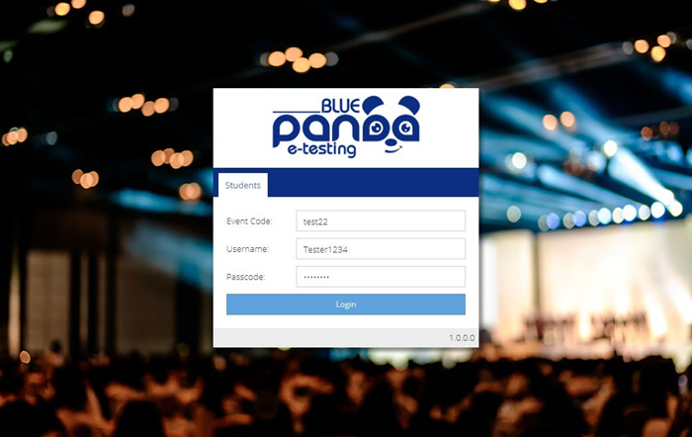

**Step 4:** Once logged in, the assigned tests will display. Click “Select” on the desired test to begin.

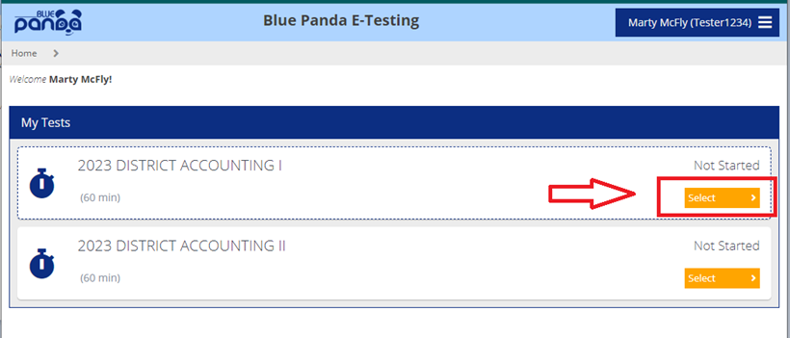

**Step 5:** Click the Start Test button to begin the test. Click submit once completed with the test.

