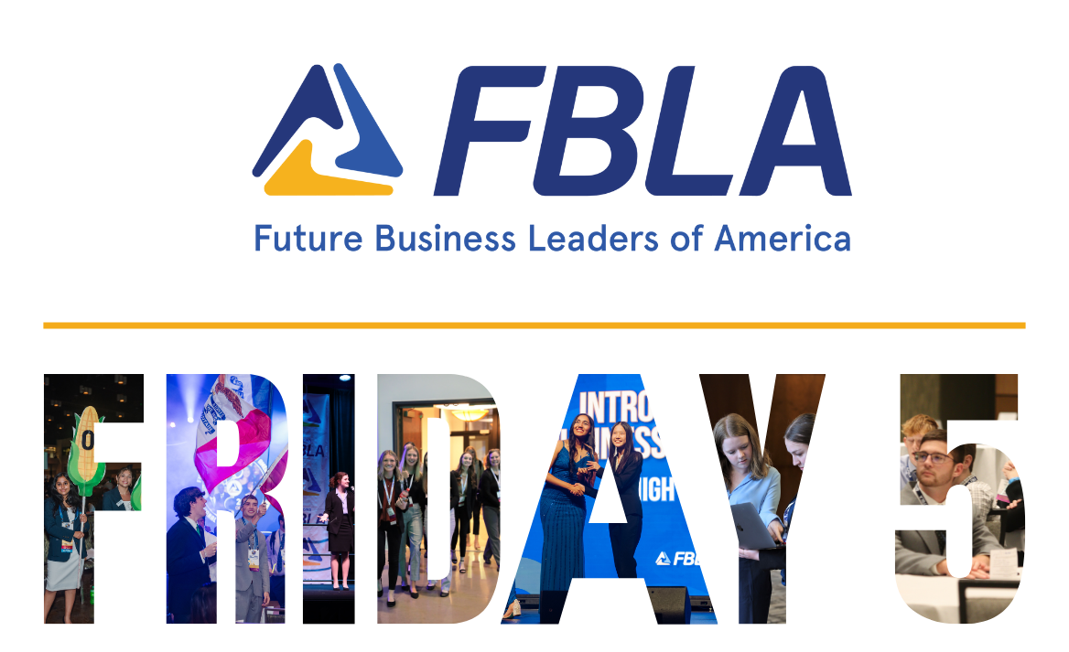
We look forward to seeing many of you on Sunday for the 2024 State Fall Leadership Conference!

1. Annual FBLA Survey - Each year, Iowa FBLA asks local chapters to complete two surveys. The Local Chapter Data survey collects data on chapters involvement and programming. While the Local Adviser Data survey collects information on local advisers to support professional development and adviser compensation. Please note, you’ll be required to sign into Connect before completing the survey.
- Local Chapter Data Survey Link - Deadline November 1, 2024
- Local Adviser Data Survey Link - Deadline November 1, 2024

2. Career Specific Event - Iowa Wild - Interested in learning more about sports and entertainment, game day operations, or event management? Then you should attend this event on December 8! Registration is $50/attendee and includes game admission, $10 meal card, t-shirt, and Wells Fargo scavenger hunt. Deadline to register is November 22, 2024. More information can be found at www.iowafbla.org/cse

3. Student Connect Accounts - Have members create FBLA Connect accounts. There are several ways to assist student members with account creation. The easiest way to do so, is loggin in as the adviser then clicking on ‘Members’ > ‘Send Activation Emails”. The student will then get an email from mail@fbla.org to create an account. If the student didn’t get an email, or may have previously registered, direct them to connect.fbla.org and click on Login and then ‘Forgot Password’.

4. Competitive Events Released - View the 2024-25 detailed event guidelines at: iowafbla.org/hs-competitive-events To view the guidelines, you’ll click on the event guidelines, then login to Connect to view the guidelines. Students can also access the guidelines after they login to Connect.

5. Requesting State Officers - You have the opportunity for a state officer to visit virtually or in person with your chapter or district. State officers can install officers, induct new members, lead activities, present FBLA opportunities, and so much more! Complete this form to request a state officer.

Dare to Lead. Dare to Dream.



